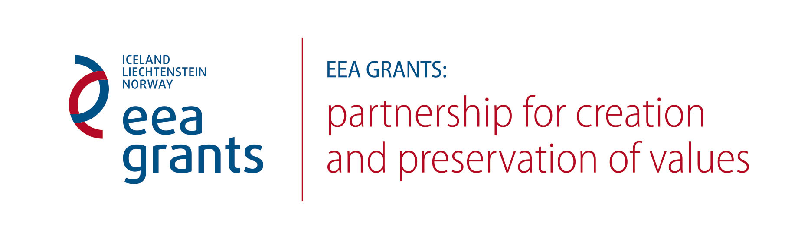
AGENDA
12 November, Europos Parkas (Education Centre), Joneikiškių village, Vilnius district
Start at 10:00 AM
9:30 –10:00. Registration
10:00–10:20. Introduction. Gintaras Karosas, Head of Public Institution Europos Parkas.
A Word of Welcome. Representative of the Ministry of Culture of the Republic of Lithuania. Representative of the Cultural Heritage Department under the Ministry of Culture of the Republic of Lithuania.
10:20–11:05. Presentation “Orangeries in European Gardens in the 17th and 18th Century“. Part I. Dr. Lars Jacob Hvinden-Haug, Norwegian Institute for Cultural Heritage Research.
11:05–11:20. Coffee break
11:20–12:05. Presentation “Orangeries in European Gardens in the 17th and 18th Century“. Part II. Dr. Lars Jacob Hvinden-Haug, Norwegian Institute for Cultural Heritage Research. Discussion
12:05–13:00. Lunch break
13:00–13:45. Presentation “Architectural Paint Research – Finding Back to Original Interior Colours”. Part I. Susanne Kaun, Norwegian Institute for Cultural Heritage Research.
13:45–14:00. Coffee break
14:00–14:45. Presentation “Architectural Paint Research – Finding Back to Original Interior Colours”. Part II. Susanne Kaun, Norwegian Institute for Cultural Heritage Research. Discussion
14:45–15:00. Coffee break
15:00–16:00. Practical advice from specialists, discussion on the subject of preservation of cultural heritage.
The presentations will be translated from English into Lithuanian.

13 November, Europos Parkas (Education Centre), Joneikiškių village, Vilnius district
Start at 10.00 AM
9:30 –10:00. Registration
10:00–11:30. Presentation “Features of Traditional Manor Architecture in the 17th and 18th Centuries“. Dr. Dalė Puodžiukienė, Institute for Architecture and Construction under the Kaunas University of Technology.
11:30–11:45. Coffee break
11.45–12.30. Presentation “Investigations into the 17th – 18th Century Architecture“. Robertas Zilinskas, architectural researcher.
12:30–13:15. Lunch break
13:15–14:00. Presentation “Architectural Investigations into the Officine and the Orangery of Liubavas Manor“. Robertas Zilinskas, architectural researcher.
14:00. Trip to Liubavas Manor

Liubavas Manor, Liubavas village, Vilnius district
14:30–15:30. Presentation of investigations and preservation works at Liubavas Manor. Gintaras Karosas, Head of Public Institution Europos Parkas.
15:30–17:00. Familiarisation with objects under restoration and practical advice from specialists. With the participation of researchers of cultural heritage objects: Dr. Dalė Puodžiukienė and Robertas Zilinskas.

